**REAL ESTATE DATA**

**INTRUDUCTION**

**I have chosen REAL_ESTATE data to create and explain visualization in Power Bi. I intend to create and Explain visualization by using Line and Clustered Column chart and Tree map and Table.**

OBJECTIVE

* **Sum of House Age and Sum of Distance to the Nearest MRT station by Number of convenience Stores.**
* **Sum of Latitude by Longitude and House price of unit area.**

DATA EXPLANATION:

* **TRANSACTION DATE:** It is refer to the specific date when the legal ownership of a house officially transfers from the seller to the buyer, marking the completion of the sale and signifying that the buyer now owns the property.
* HOUSE AGE: **The number of years or days since the house was built.**
* **Distance to Nearest MRT station: The distance from the house to the nearest Mass Rapid Transit station.**
* Number of convenience stores: **It shows how many stores are available in particular area.**
* **Latitude:** **Latitude specifies the North-South position of the house on the earth surface.**
* Longitude: **Longitude specifies the East-West position of the house.**
* House price per Unit area: **The price of the house per square unit of area.**

**VISUALIZATION-EXPLANATION**

**LINE AND COLUMN CHART**

* **I am taking line and clustered column chart to show how many convenience stores contain per**

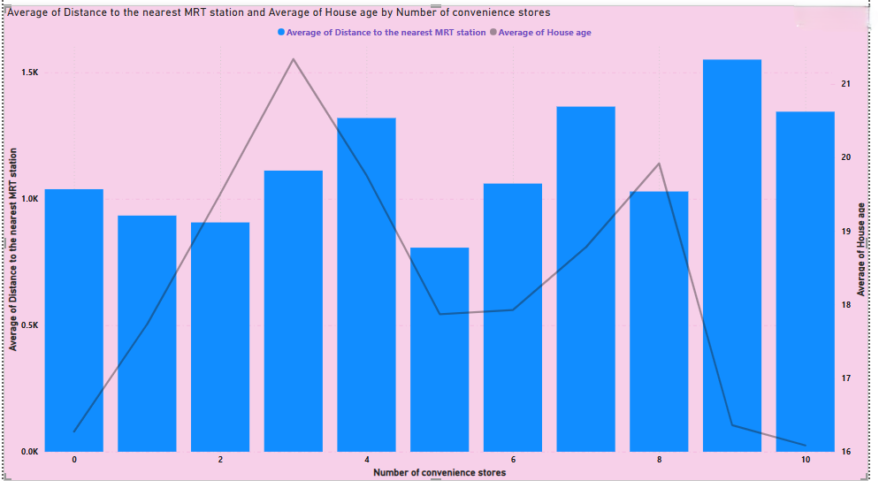

**house and also show how much distance to the nearest MRT station from the houses.**

**SLICER**

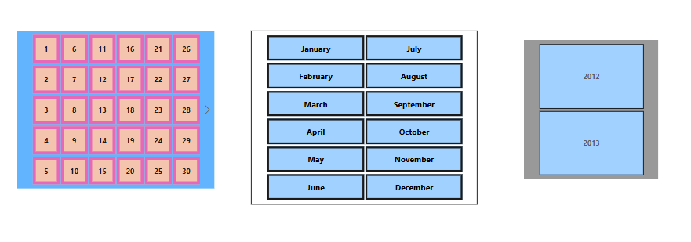

* **Now I am taking to slicer to show the transaction date like day,month,year.**
* **I am trying to figure out what to say to show in to the slicer to show the particular date,monthand year which location to sale the house.**

**TABLE**

**Now I am Taking Table to show Sum of House Age, Sum of House Price of Unit Area, Sum of Distance to the Nearest MRT Station , Sum of Number of Convenience Stores.**

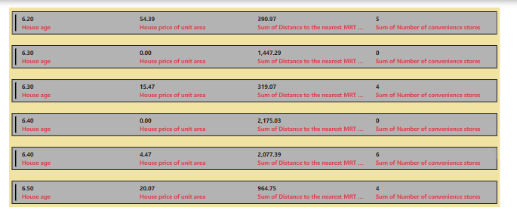

MAP

**Here I am taking 2nd page . In 2nd page I am taking Map to show Latitude and Longitude.**

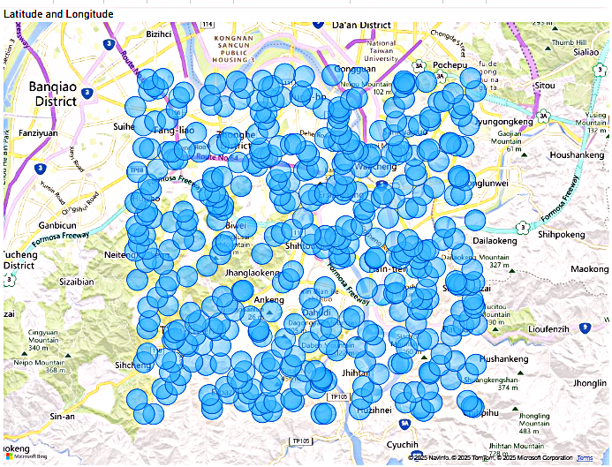

**CONCLUSION**

**Finally the analysis show that areas with more convenience stores and better MRT access tend to have higher property demand. Older houses are often farther from MRT stations , while never developments are closer to key transport hubs . Additionally , property prices vary by location , with prime areas having higher unit prices due to better infrastructure and amenities . These insights help in making informed real estate investment decision .**